
Activities for the Week of 5/4/20
Hi Everyone! Here are some simple plans to help try to keep our kids on track during this time period:
Skills: We are currently working on tricky words. These are words that you can’t sound out and need to know “by heart.”
Please continue:
The words to review are: was, the, a, of, all, one, from, when, word, why, to, where, no, and I, what, so which, once
New tricky words for this week: said, says
You can play matching games, flashcards, and writing them. Put the words on paper and have your child bear walk and find the word and have your child use it in a sentence. You can also lift your right knee as you touch it with your left hand, then switch, as you spell the word.
Other activities can include reviewing letter sounds, if needed.
Also, a good way to maintain their reading skills is choose one of the decodable books that are on our website to review. I would suggest up to Unit 9, however if your child feels comfortable they can try 9 or 10. Click on here to practice reading Bug and Frog: ..\Desktop\bug and frog.PNG

Science: Fish
We will discussing fish this week:
Here are the videos for this week. We included 2 virtual tours of 2 aquariums, life cycle, 1 fiction and 2 nonfiction. Brain pop jr. has a video also. We also assigned stories in Epic:
https://www.youtube.com/watch?v=nYZzqZPnzPA
https://www.youtube.com/watch?v=oqupxANpqIE&t=51s
https://www.youtube.com/watch?v=8CM3PcRQ8NI
https://aqua.org/media/virtualtours/washington/index.html
https://www.georgiaaquarium.org/
Writing for the week:
https://www.youtube.com/watch?v=ZUKJjVXT0Ko
Please listen to the story swimmy. Please draw, label, and write a sentence about your favorite part of the story. We will use these writings to share at zoom. Please take a picture of your child’s drawing and email it to Mrs. Kamauf by Thursday night. You can also send it to me send it to me through dojo (through a message or portfolio)

WIN: Here are some strategies that will be helpful for you when your child is reading a story especially on the assigned books on Raz Kids. These are strategies they are used to using. They are called beanie baby strategies. We have assigned each child stories in RazKids to read and then they can take the quiz. Remember to have them practice the story a couple of times before taking the quiz. Please look at the message section on your child’s page in Razkids. We left some of you messages. Here they are the Beany Baby strategies:
Click on this link to view bigger: WIN\BeanyBabyDecodingforParents.pdf
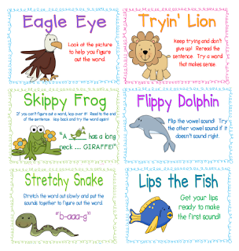

We were going to start these strategies for answering questions about stories: Click on this link to see it bigger: WIN\BeanyBabyComprehensionforParents.pdf
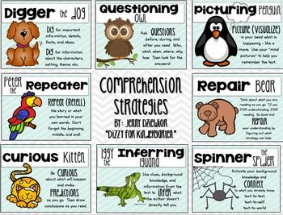
These strategies can be used with any picture book you have at home or with any of the books on Epic. Epic is not a district site so you will need to use the hyperlink, or type it into google and then use the password below.
Please log into Epic: https://www.getepic.com/students
Log in: dyz3308
Find your child’s name. After that there are great stories and videos that are available. We love Epic because of all the great stories that are on it.
We are also posting a better poster of the Beanie Baby Strategies that you can print on our Classroom website.

Math:
Please make sure your child takes his/her placement test on happy numbers this week.
Our new focus for online math is happy numbers. You can find the class code and your child’s password from our April 19th post on dojo. If you can’t find it, please let us know. If your child has not taken their placement test yet, please have them do it this week. You can read the questions to them but please do not help them with answers so the assessment can accurately place them and give them appropriate math activities.
Activities:
Review: Please continue to work on addition and subtraction facts to 5. Students should be fluent at this. You can put them on flash cards, do them orally, make it into a game or create movement when practicing them. If you need some ideas, let us know. Below are the math videos we have provided. Feel free to watch any of those.
New: Have your child work on identifying and writing numbers 13 and 14. Help them understand that 13 is 10 and 3 ones, and 14 is 10 and 4 ones. Here is a video on teen numbers
https://www.youtube.com/watch?v=1W5aYi3lkho

The following are videos for the week. We added a song on subtraction.
Count to 100: https://www.youtube.com/watch?v=0TgLtF3PMOc
Count by 10s: https://www.youtube.com/watch?v=-gmEe0-_ex8
Count by 5s: https://www.youtube.com/watch?v=_awKlEMyleA
Please practice counting by one of these videos.

Try this addition game on abcya.com
https://www.abcya.com/games/addition
Here is a video on math facts to 5.
https://www.youtube.com/watch?v=uRoJ5E-Xx9s
Pirate subtraction song
https://www.youtube.com/watch?v=QkPa9V2wtZs

